BIG DATA ANALYTICS LAB
List of Experiments:
1. Implement a simple map-reduce job that builds an inverted index on the set of input documents (Hadoop)
2. Process big data in HBase
3. Store and retrieve data in Pig
4. Perform Social media analysis using cassandra
5. Buyer event analytics using Cassandra on suitable product sales data.
6. Using Power Pivot (Excel) Perform the following on any dataset a) Big Data Analytics b) Big Data Charting
7. Use R-Project to carry out statistical analysis of big data
8. Use R-Project for data visualization of social media data

1. Implement a simple map-reduce job that builds an inverted index on the set of input documents (Hadoop)

Hadoop MapReduce Inverted Index
This is a Java program for creating an inverted index of words occurring in a large set of documents extracted from web pages using Hadoop MapReduce and Google Dataproc.
As our dataset, we are using a subset of 74 files from a total of 408 files (text extracted from HTML tags) derived from the Stanford WebBase project that is available here. It was obtained from a web crawl done in February 2007. It is one of the largest collections totaling more than 100 million web pages from more than 50,000 websites. This version has already been cleaned.
In this project we first set up a sample Hadoop cluster using Local (Standalone) Mode and then implement the actual project in Fully-Distributed Mode on Google Dataproc on the actual data set.

Local (Standalone) Mode

Setup Hadoop
We need to setup the project on GNU/Linux as it is the supported development and production platform for Hadoop. To get a Hadoop distribution, download a recent stable release from one of the Apache Download Mirrors. Please note that this project was deployed and tested using hadoop-3.1.1. Unpack the downloaded Hadoop distribution. In the distribution folder, edit the file etc/hadoop/hadoop-env.sh to define environment variable parameters as follows:
# add these line to the hadoop-env.sh or set them in terminal
export JAVA_HOME=/usr/java/latest
export PATH=${JAVA_HOME}/bin:${PATH}
export HADOOP_CLASSPATH=${JAVA_HOME}/lib/tools.jar
Then try the following command:
$ bin/hadoop
This should display the usage documentation for the Hadoop script. Now you are ready to start your Hadoop cluster in the standalone mode.

Setup and run a simple Hadoop job
This simple Hadoop job, gets two text files from the "input" folder as the arguments of the Mapper.
#file01
5722018411 Hello World Bye World
#file02
6722018415 Hello Hadoop Goodbye Hadoop
And by submitting a Hadoop job and applying Reduce step, it generates an inverted index as below:
bye 5722018411:1
goodbye 6722018415:1
hadoop 6722018415:2
hello 5722018411:1 6722018415:1
world 5722018411:2
To submit a Hadoop job, the MadReduce implementation should be packaged as a jar file. To do so, copy the InvertedIndex.java file of this project to the Hadoop's distribution root folder and while you are still there run the following commands to compile InvertedIndex.java and create a jar file.
$ bin/hadoop com.sun.tools.javac.Main InvertedIndex.java
$ jar cf invertedindex.jar InvertedIndex*.class
Copy input/file01 and input/file02 of this project and place them inside the input folder of the Hadoop distrubution folder. While you are still there, run the following command to submit the job, get the input files from input folder, generate the inverted index and store its output in the output folder:
$ bin/hadoop jar invertedindex.jar InvertedIndex input output
And finally to see the output, run the below command:
$ bin/hadoop dfs -cat output/part-r-00000

Fully-Distributed Mode
In this section we create a cluster with 3 worker nodes on Google Dataproc and run invertedindex.jar job on the actual data set.

2. Process big data in HBase

What is HBase
Hbase is an open source and sorted map data built on Hadoop. It is column oriented and horizontally scalable.
It is based on Google's Big Table.It has set of tables which keep data in key value format. Hbase is well suited for sparse data sets which are very common in big data use cases. Hbase provides APIs enabling development in practically any programming language. It is a part of the Hadoop ecosystem that provides random real-time read/write access to data in the Hadoop File System.

Why HBase
- RDBMS get exponentially slow as the data becomes large
- Expects data to be highly structured, i.e. ability to fit in a well-defined schema
- Any change in schema might require a downtime
- For sparse datasets, too much of overhead of maintaining NULL values

Features of Hbase
- Horizontally scalable: You can add any number of columns anytime.
- Automatic Failover: Automatic failover is a resource that allows a system administrator to automatically switch data handling to a standby system in the event of system compromise
- Integrations with Map/Reduce framework: Al the commands and java codes internally implement Map/ Reduce to do the task and it is built over Hadoop Distributed File System.
- sparse, distributed, persistent, multidimensional sorted map, which is indexed by rowkey, column key,and timestamp.
- Often referred as a key value store or column family-oriented database, or storing versioned maps of maps.
- fundamentally, it's a platform for storing and retrieving data with random access.
- It doesn't care about datatypes(storing an integer in one row and a string in another for the same column).
- It doesn't enforce relationships within your data.
- It is designed to run on a cluster of computers, built using commodity hardware.

HBase Data Model

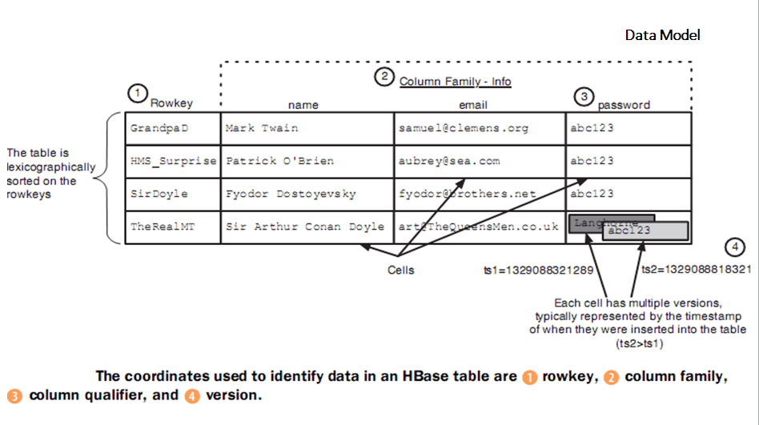

3. Store and retrieve data in Pig
In general, Apache Pig works on top of Hadoop. It is an analytical tool that analyzes large datasets that exist in the Hadoop File System. To analyze data using Apache Pig, we have to initially load the data into Apache Pig. This chapter explains how to load data to Apache Pig from HDFS.

Preparing HDFS
In MapReduce mode, Pig reads (loads) data from HDFS and stores the results back in HDFS. Therefore, let us start HDFS and create the following sample data in HDFS.
Student ID | First Name | Last Name | Phone | City
001 | Rajiv | Reddy | 9848022337 | Hyderabad
002 | siddarth | Battacharya | 9848022338 | Kolkata
003 | Rajesh | Khanna | 9848022339 | Delhi
004 | Preethi | Agarwal | 9848022330 | Pune
005 | Trupthi | Mohanthy | 9848022336 | Bhuwaneshwar
006 | Archana | Mishra | 9848022335 | Chennai
The above dataset contains personal details like id, first name, last name, phone number and city, of six students.

Step 1: Verifying Hadoop
First of all, verify the installation using Hadoop version command, as shown below.
$ hadoop version
If your system contains Hadoop, and if you have set the PATH variable, then you will get the following output −
Hadoop 2.6.0
Subversion https://git-wip-us.apache.org/repos/asf/hadoop.git -r
e3496499ecb8d220fba99dc5ed4c99c8f9e33bb1
Compiled by jenkins on 2014-11-13T21:10Z
Compiled with protoc 2.5.0
From source with checksum 18e43357c8f927c0695f1e9522859d6a
This command was run using /home/Hadoop/hadoop/share/hadoop/common/hadoop
common-2.6.0.jar

Step 2: Starting HDFS
Browse through the sbin directory of Hadoop and start yarn and Hadoop dfs (distributed file system) as shown below.
cd /$Hadoop_Home/sbin/
$ start-dfs.sh
localhost: starting namenode, logging to /home/Hadoop/hadoop/logs/hadoopHadoop-namenode-localhost.localdomain.out
localhost: starting datanode, logging to /home/Hadoop/hadoop/logs/hadoopHadoop-datanode-localhost.localdomain.out
Starting secondary namenodes [0.0.0.0]
starting secondarynamenode, logging to /home/Hadoop/hadoop/logs/hadoop-Hadoopsecondarynamenode-localhost.localdomain.out

$ start-yarn.sh
starting yarn daemons
starting resourcemanager, logging to /home/Hadoop/hadoop/logs/yarn-Hadoopresourcemanager-localhost.localdomain.out
localhost: starting nodemanager, logging to /home/Hadoop/hadoop/logs/yarnHadoop-nodemanager-localhost.localdomain.out

Step 3: Create a Directory in HDFS
In Hadoop DFS, you can create directories using the command mkdir. Create a new directory in HDFS with the name Pig_Data in the required path as shown below.

$cd /$Hadoop_Home/bin/
$ hdfs dfs -mkdir hdfs://localhost:9000/Pig_Data

Step 4: Placing the data in HDFS
The input file of Pig contains each tuple/record in individual lines. And the entities of the record are separated by a delimiter (In our example we used “,”).
In the local file system, create an input file student_data.txt containing data as shown below.
001,Rajiv,Reddy,9848022337,Hyderabad
002,siddarth,Battacharya,9848022338,Kolkata
003,Rajesh,Khanna,9848022339,Delhi
004,Preethi,Agarwal,9848022330,Pune
005,Trupthi,Mohanthy,9848022336,Bhuwaneshwar
006,Archana,Mishra,9848022335,Chennai.
Now, move the file from the local file system to HDFS using put command as shown below. (You can use copyFromLocal command as well.)
$ cd $HADOOP_HOME/bin
$ hdfs dfs -put /home/Hadoop/Pig/Pig_Data/student_data.txt dfs://localhost:9000/pig_data/

Verifying the file
You can use the cat command to verify whether the file has been moved into the HDFS, as shown below.
$ cd $HADOOP_HOME/bin
$ hdfs dfs -cat hdfs://localhost:9000/pig_data/student_data.txt

Output
You can see the content of the file as shown below.
15/10/01 12:16:55 WARN util.NativeCodeLoader: Unable to load native-hadoop
library for your platform... using builtin-java classes where applicable

001,Rajiv,Reddy,9848022337,Hyderabad
002,siddarth,Battacharya,9848022338,Kolkata
003,Rajesh,Khanna,9848022339,Delhi
004,Preethi,Agarwal,9848022330,Pune
005,Trupthi,Mohanthy,9848022336,Bhuwaneshwar
006,Archana,Mishra,9848022335,Chennai

Apache Pig - Storing Data

In the previous chapter, we learnt how to load data into Apache Pig. You can store the loaded data in the file system using the store operator. This chapter explains how to store data in Apache Pig using the Store operator.

Syntax
Given below is the syntax of the Store statement.
STORE Relation_name INTO ' required_directory_path ' [USING function];
Assume we have a file student_data.txt in HDFS with the following content.
001,Rajiv,Reddy,9848022337,Hyderabad
002,siddarth,Battacharya,9848022338,Kolkata
003,Rajesh,Khanna,9848022339,Delhi
004,Preethi,Agarwal,9848022330,Pune
005,Trupthi,Mohanthy,9848022336,Bhuwaneshwar
006,Archana,Mishra,9848022335,Chennai.
And we have read it into a relation student using the LOAD operator as shown below.
grunt> student = LOAD 'hdfs://localhost:9000/pig_data/student_data.txt'
USING PigStorage(',')
as ( id:int, firstname:chararray, lastname:chararray, phone:chararray,
city:chararray );
Now, let us store the relation in the HDFS directory “/pig_Output/” as shown below.
grunt> STORE student INTO ' hdfs://localhost:9000/pig_Output/ ' USING PigSto

Output
After executing the store statement, you will get the following output. A directory is created with the specified name and the data will be stored in it.
2015-10-05 13:05:05,429 [main] INFO org.apache.pig.backend.hadoop.executionengine.mapReduceLayer.
MapReduceLau ncher - 100% complete
2015-10-05 13:05:05,429 [main] INFO org.apache.pig.tools.pigstats.mapreduce.SimplePigStats -
Script Statistics:

HadoopVersion PigVersion UserId StartedAt FinishedAt Features
2.6.0 0.15.0 Hadoop 2015-10-0 13:03:03 2015-10-05 13:05:05 UNKNOWN
Success!
Job Stats (time in seconds):
JobId Maps Reduces MaxMapTime MinMapTime AvgMapTime MedianMapTime
job_14459_06 1 0 n/a n/a n/a n/a
MaxReduceTime MinReduceTime AvgReduceTime MedianReducetime Alias Feature
0 0 0 0 student MAP_ONLY
OutPut folder
hdfs://localhost:9000/pig_Output/

Input(s): Successfully read 0 records from: "hdfs://localhost:9000/pig_data/student_data.txt"
Output(s): Successfully stored 0 records in: "hdfs://localhost:9000/pig_Output"
Counters:
Total records written : 0
Total bytes written : 0
Spillable Memory Manager spill count : 0
Total bags proactively spilled: 0
Total records proactively spilled: 0

Job DAG: job_1443519499159_0006

2015-10-05 13:06:06,192 [main] INFO org.apache.pig.backend.hadoop.executionengine
.map Reduce Layer. Map Reduce Launcher - Success!

4. Perform Social media analysis using Cassandra

Cassandra is a distributed database management system designed for handling a high volume of structured data across commodity servers.
Cassandra handles the huge amount of data with its distributed architecture. Data is placed on different machines with more than one replication factor that provides high availability and no single point of failure.
In the image below, circles are Cassandra nodes and lines between the circles shows distributed architecture, while the client is sending data to the node.
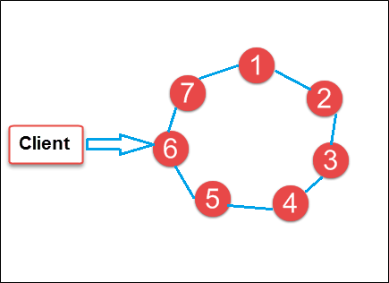

5. Buyer event analytics using Cassandra on suitable product sales data.
To begin with, let’s explore what is required from the Cassandra perspective to store the data. To do this on a basic level, we only need a very a simple schema. Let’s start with two tables: one to capture basic customer information and another to log card transactions:

CREATE TABLE cc.cc_customers (
id text PRIMARY KEY,
county text,
name text
);

CREATE TABLE cc.cc_transactions (
customerid text,
year int,
month int,
id timeuuid,
amount int,
card text,
status text,
PRIMARY KEY ((customerid, year, month), id)
);

Use Case 1: Calculating current account balances
A reasonable request from any customer is to understand what is their current balance on each of their cards. When asked the question: given my customer id and card, how much money do I have? In this case our application would need to answer with a single number, the sum of all completed transactions and repayments on that particular card.

Option 1: Calculate on the fly
One possible way of implementing this requirement would be to read the full transaction history of that particular user and calculate the balance on the fly. It is easy to see that this would not be a good idea – we would need to query a potentially large amount of data from multiple partitions, which could be quite slow. Even worse, the number of these partitions would keep increasing with time, resulting in even slower and slower queries.
The only advantage of this approach is that we would always be guaranteed of getting a correct balance at any given time. The read complexity and latency however, makes it a bad choice.

Option 2: Store the latest account balance
An alternative approach would be to maintain a balance for each card at the time of capturing the card transactions. This might seem a better way, but also has several serious problems:
- It would be necessary to read the current balance before every transaction in order to be able to adjust it².
- Given Cassandra does not support ACID transactions, it’s difficult to ensure that the balance is correct:
  - No card transactions are missed
  - None of them are added up twice
  - Concurrent updates don’t corrupt the result
- Status changes in transactions need to be dealt with
- It impacts write latency which is likely to be important if we want to capture a large amount of transactions

6. Using Power Pivot (Excel) Perform the following on any dataset
a) Big Data Analytics b) Big Data Charting

According to Microsoft, “Power Pivot is an Excel add-in you can use to perform powerful data analysis and create sophisticated data models. With Power Pivot, you can mash up large volumes of data from various sources, perform information analysis rapidly, and share insights easily.”

Sample Data

We will use two data sets for our learning purpose. One is the Customer Info table, and the other is the Order Info table. Both the tables have CustomerID as the common field.
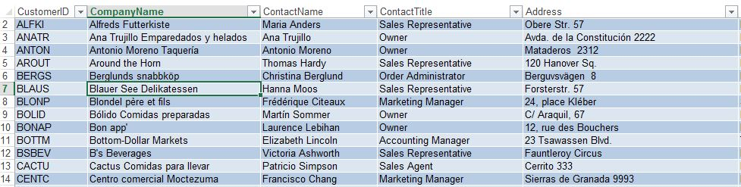
Fig: Customer Info



Fig: Order Info

How to Get the Excel Power Pivot Add-In
- Open Excel.
- Select File > Options.


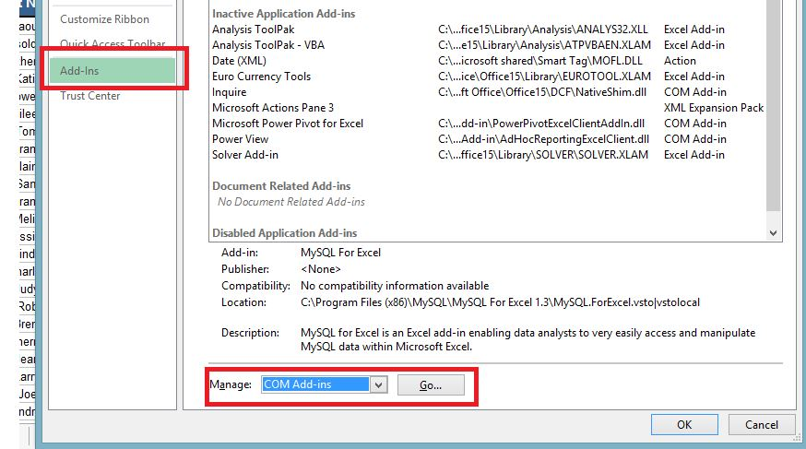

- Select Add-Ins.
- Select the Manage drop down menu, then select COM Add-ins.
- Select Go.
- Select Microsoft Power Pivot Excel.
- Select OK. It adds the Power Pivot tab to Excel.

7. Use R-Project to carry out statistical analysis of big data

